AMt. Hamilton Optics Cleaning Trip #10
David Hilyard and Brian DuPraw
11/3/11

Hamilton Collimator
One of our tasks for this trip was to remove the Hamilton Spectrograph’s collimator mirror, which had developed a poor coating over time. This is a phenomenon that has been observed repeatedly in the past, necessitating fairly frequent re-coating. The plan is to re-coat it once more before our coating chamber is disassembled for the new pumping system to be installed, which would delay any such projects. We measured the reflectivity once it was back in the Optical Shop and found it to be greater than the reference mirror. We zeroed the reflectometer on the collimator and then measured the reference mirror to be 97% of the collimator’s reflectivity with the blue filter and 94% with the red.
There was a yellow triangle on the back of the cell that a scribe mark on the mirror aligned with. The scribe mark was labeled “To edge.” Similarly, there was another scribe mark near the middle. The cell was held on by four hex-driven bolts around the perimeter and a long driver of the appropriate size was conveniently located nearby.

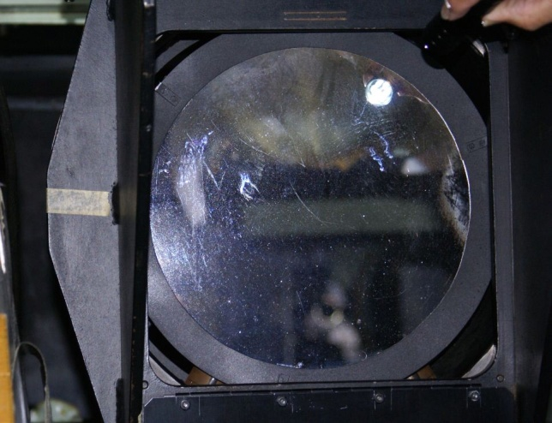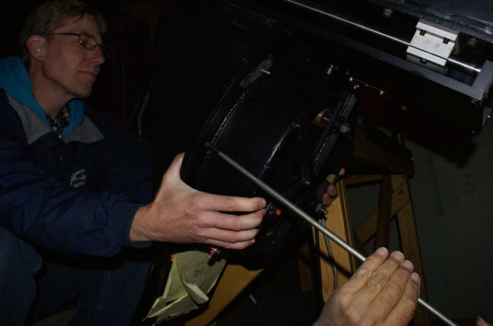
Condition as mounted Holding the mirror cell as bolts are removed

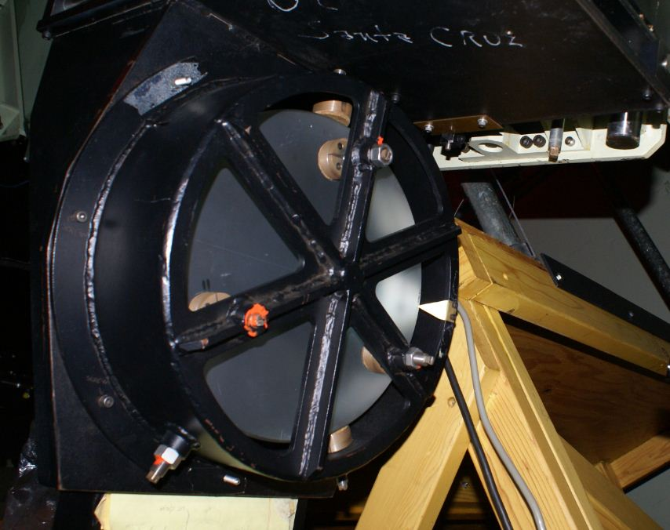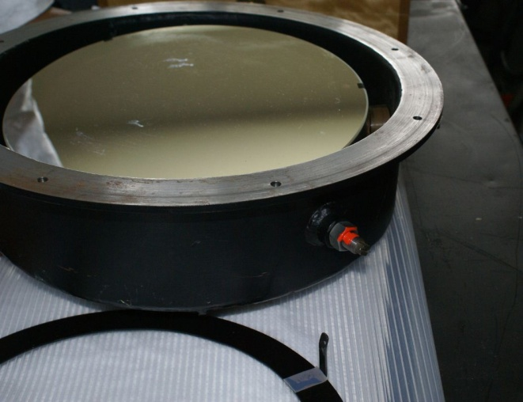
Registration marks Cell with ring removed

The cell for the collimator mirror had three cork pads that it rested on. We were careful not to change their settings, since they determined the alignment of the optic in the system. There were also three cork pads along the inside wall, keeping the mirror centered.

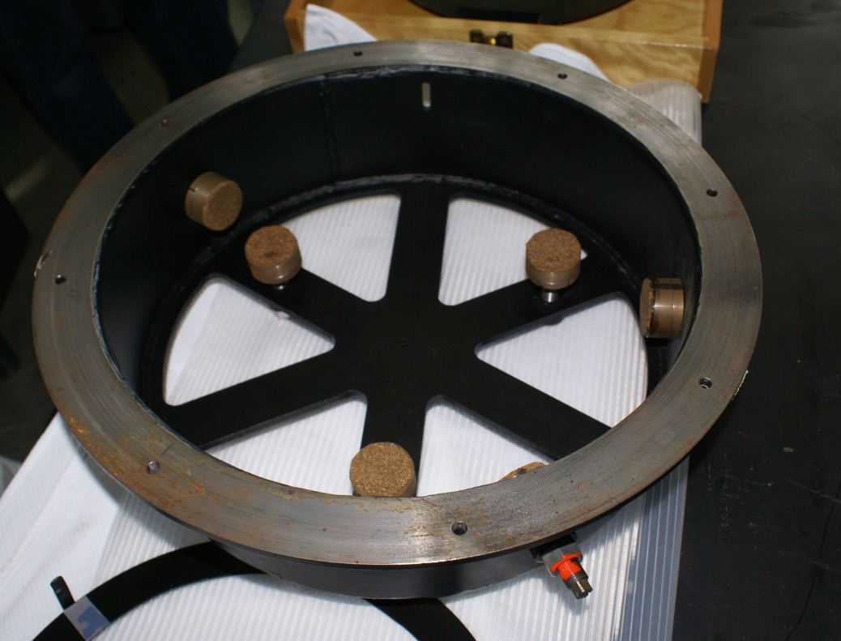

APF Primary
The Automated Planet Finder had had leaf and dust-excluding filters installed around its perimeter since we were last there. We removed one segment to inspect the horizontally-oriented mirror and measure its reflectivity. At Coating Measurement Position #2 (marked on the mirror’s edge) we measured 92% with the red filter and 85% with the blue, relative to the standard reference.
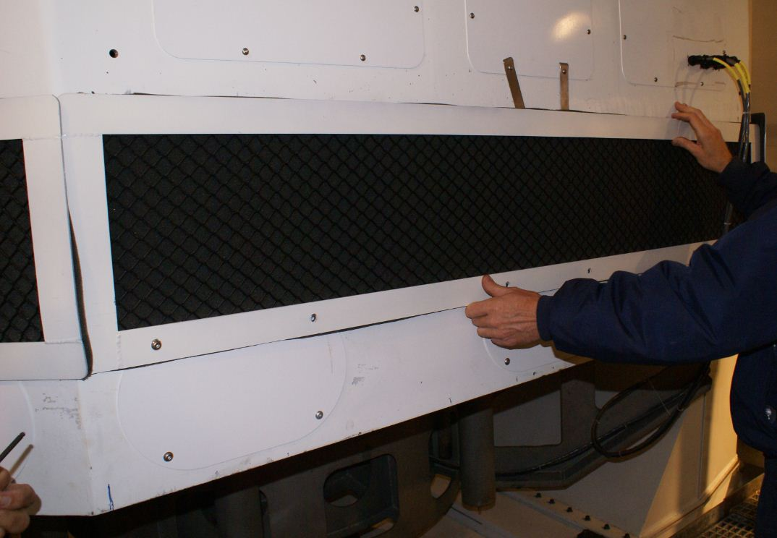

In addition to those tasks, we were interested in taking photographs of what would be the low edge of the mirror when it was placed vertically, to assist the engineering team with the design of a trough to catch cleaning fluid. In this picture what would be the low edge of the mirror is toward the upper-right image quadrant.

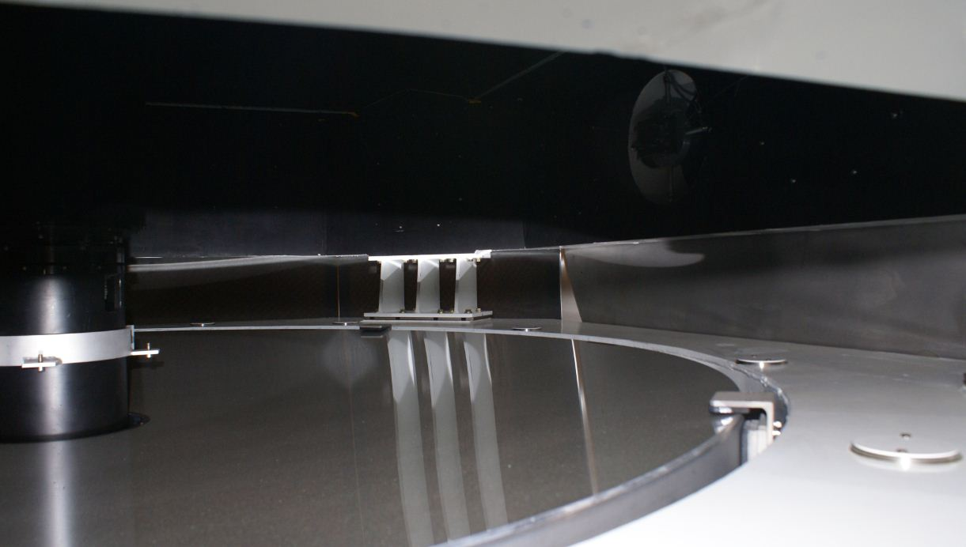
Low edge when vertical
Mounting Bracket
Mounting Bracket

There was a thin layer of dust on the primary mirror but we didn’t see the large blown-in debris that had occasionally been seen before the filter installation.

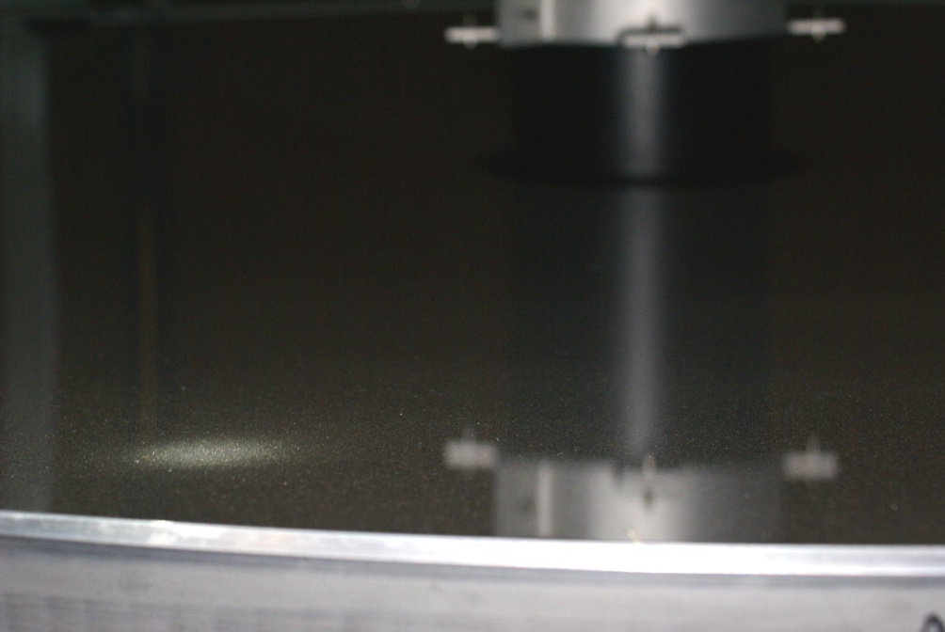
Dust layer

120” Shane Reflector Coude Secondary
The Coude’ Secondary was on the dome floor and we inspected it there. There were pits in the surface, with the largest being about ¾” diameter. There was also an overall haze, upon which cleaning had no effect. We measured the reflectivity to be 83% in the red near the edge and 87% in the blue. Close to the center it was 86% in the red and 90% in the blue.
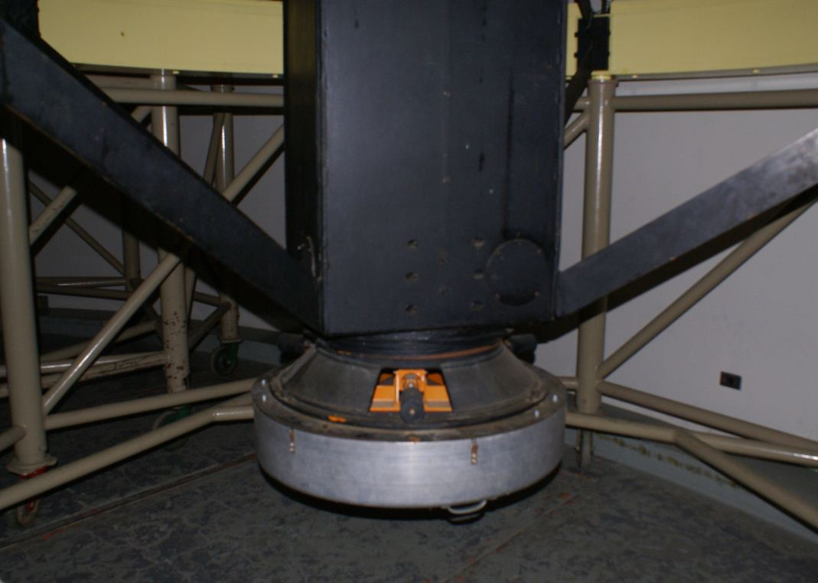

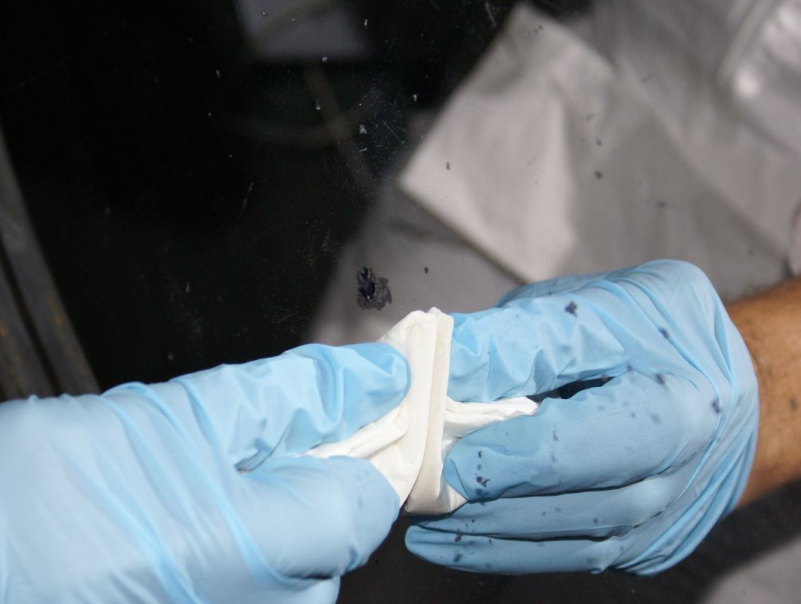
Surface defects

120” Shane Reflector Coude #3
The Coude’ Mirror #3 was on the dome floor and Donnie opened the protective cover manually. There were two obvious bird poop spots and a thin layer of dust overall. Dave cleaned the bird poop first with an Orvus/acetone/H2O solution and then cleaned the entire mirror with that followed by ethanol. Afterward it appeared significantly cleaner. Before cleaning we measured 98% reflectivity in the red and 89% in the blue. Afterwards the red was the same but the blue reflectivity had increased to 95%
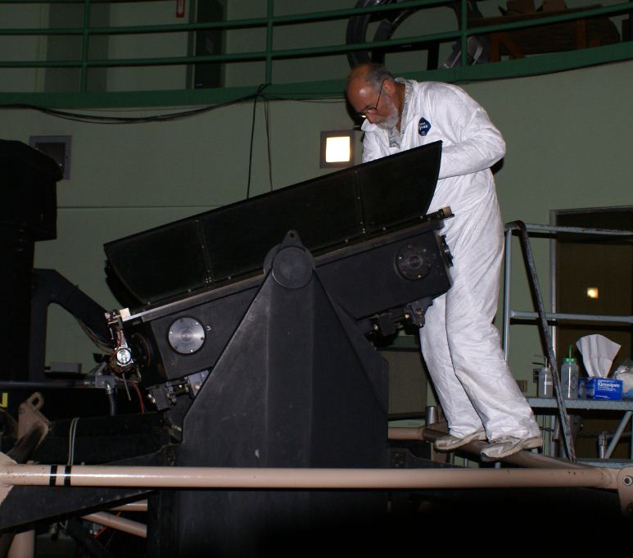

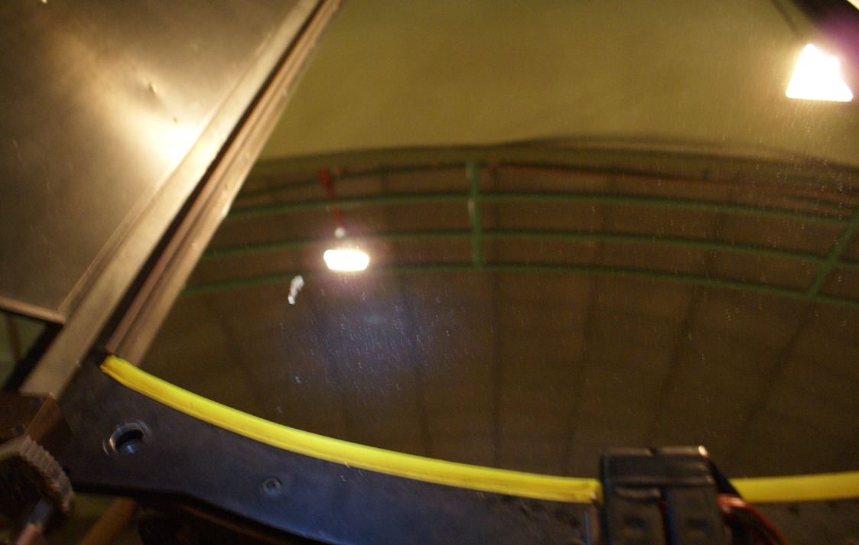
Bird poop and dust

Adaptive Optics
Dave blew off a number of optical elements in the Adaptive Optics room using a hand-held can of compressed air. The optics were typically covered by taped on plastic lens covers that were easily removed. He cleaned a few of the elements with ethanol.

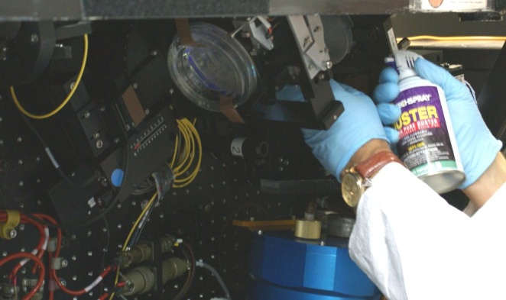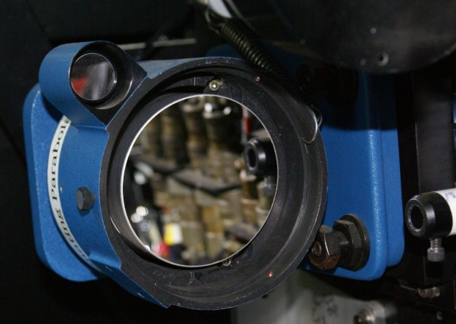

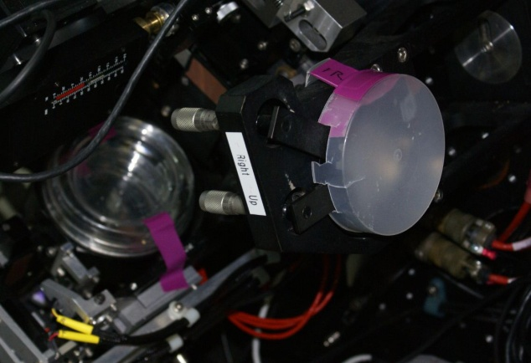

One optic Dave did NOT touch was the deformable mirror, as it was considered too risky to do so.

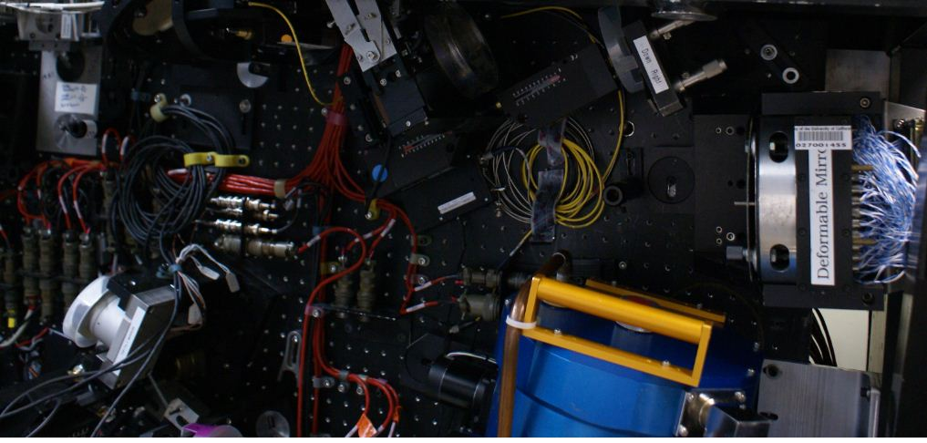

40” Telescope
Dave was able to climb inside the tube of the 40” primary to check its condition and measure the reflectivity. It was 85% in the red and 84% in the blue. It was dusty but not too bad overall. He cleaned a 6” diameter area and it appeared shinier but it also developed sleeks so he stopped.

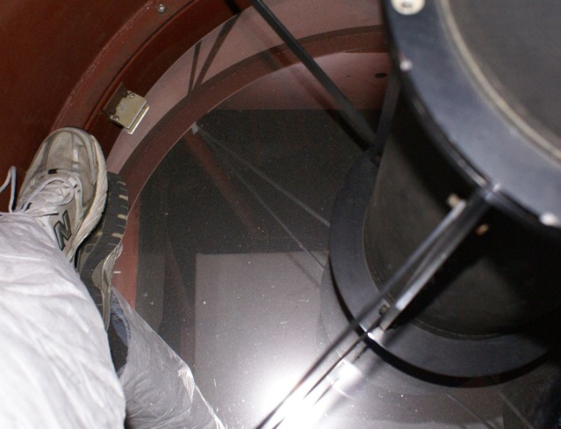

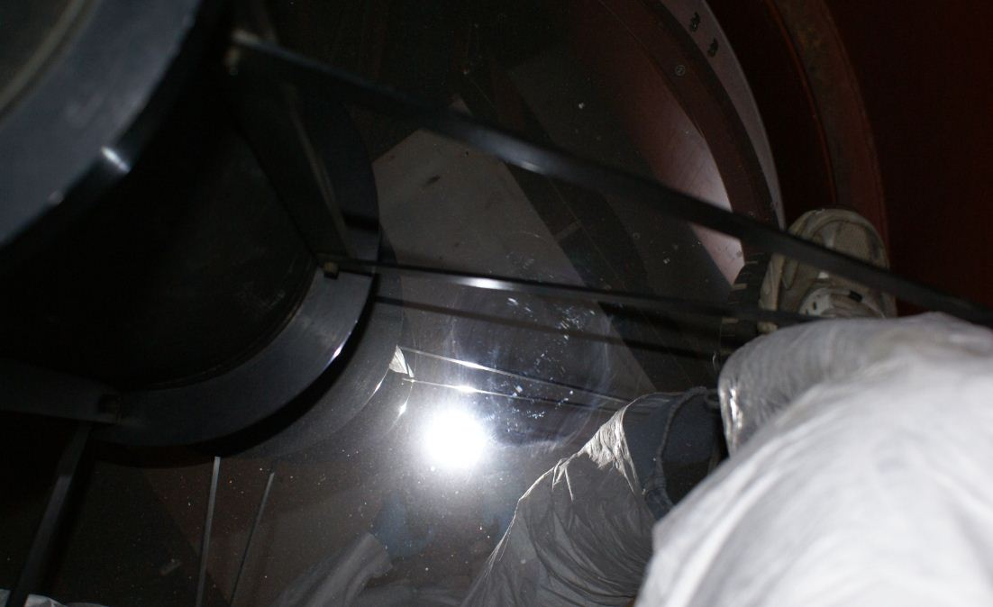
Cleaned area… easily sleeked

The secondary mirror had an overall haze to it. Dave tried cleaning it and, although it didn’t sleek, the haze didn’t go away either. We measured the reflectivity to be 77% in the red and 84% in the blue.
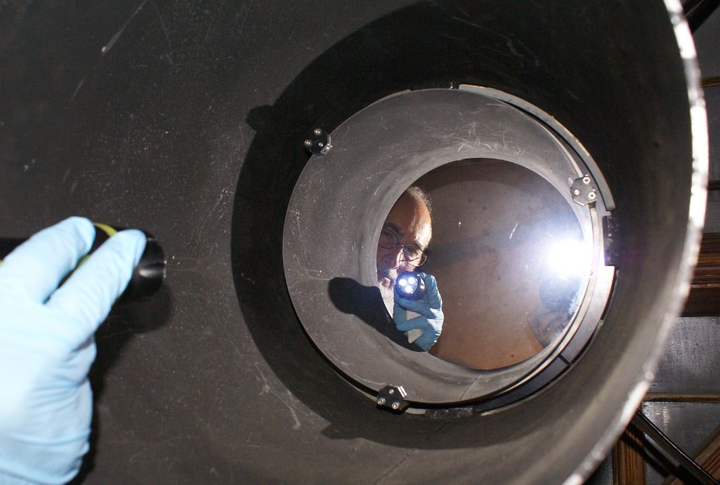

Prime Focus Camera
The bottom cover was removed but it was determined that no improvements could be made on that end. The top cover appeared to be secured with electrical connections and more, so it was left alone for this trip.
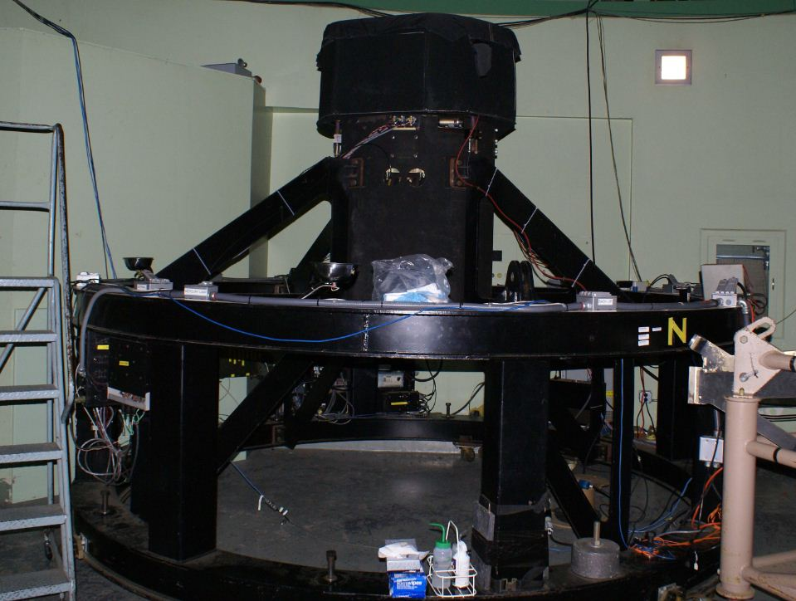

Tauchman
Dave cleaned the tertiary mirror, the spotting scope and an eyepiece using ethanol. There was significant improvement.

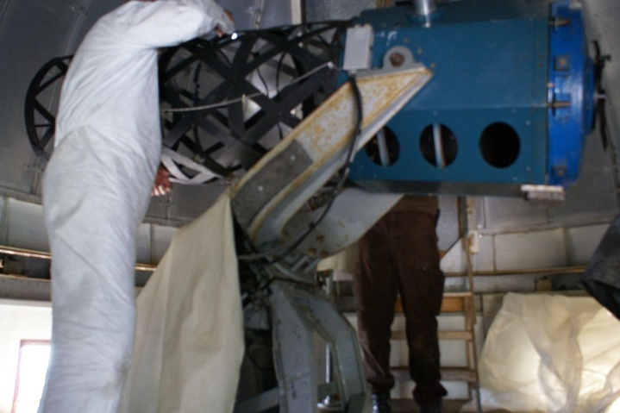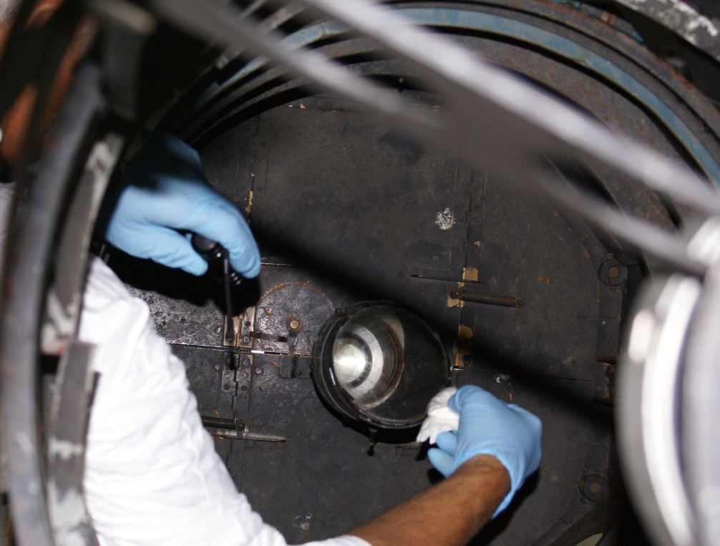

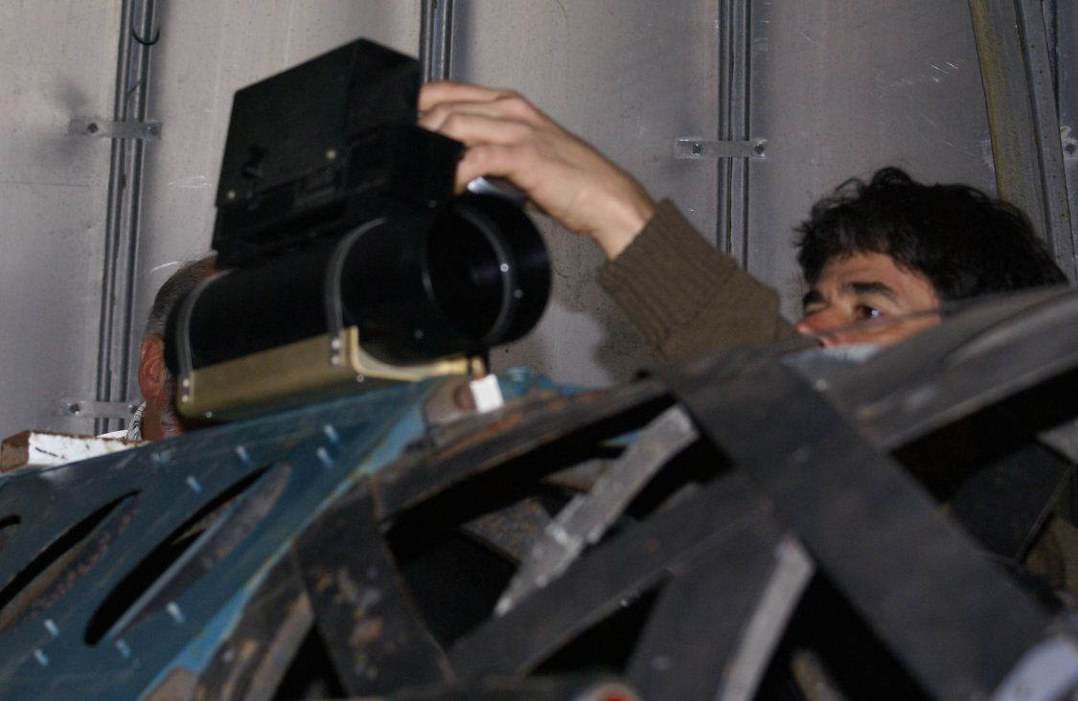

Livermore Telescope Donation
There was a stored ½-meter telescope in the light tunnel below the Shane 120” telescope that we examined. It was believed to have been donated some time ago by Lawrence Livermore National Lab. Dave was able to clean a section of the dusty primary successfully but time to do the entire mirror had not been budgeted for this trip. The coating seemed robust though.

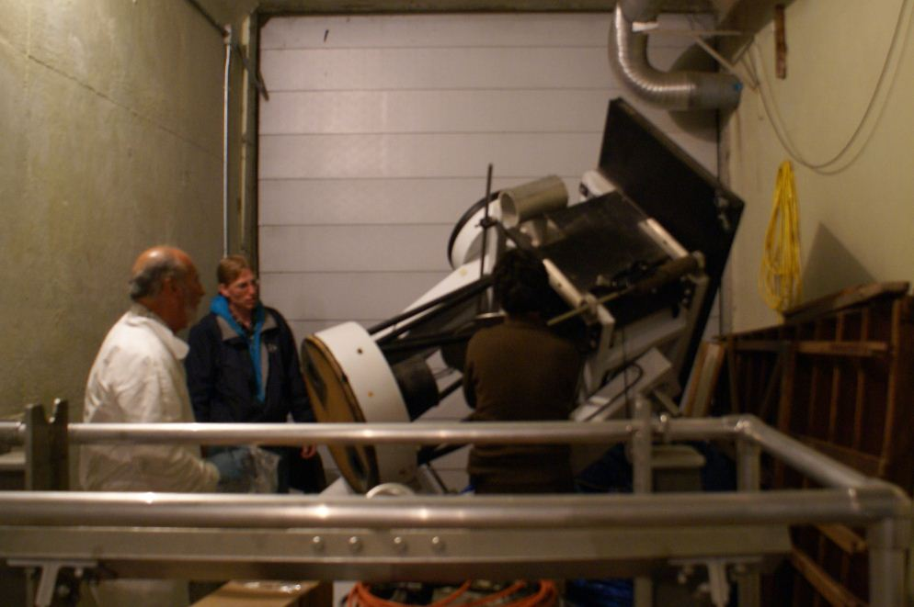

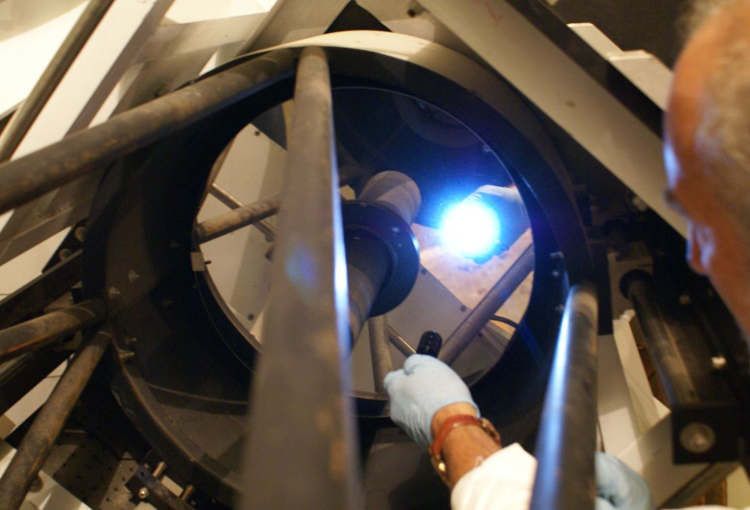

Keck Test Segment
Also in the light tunnel was a 6’ square crate with “Schott” marked on the lid. We opened it and found an unknown hexagonal piece of Zerodur with numerous mounting bolts protruding from the back. We later found out that Dave Cowley was aware of it and that it was a Keck test segment. It was embedded in shredded foam and a few dead mice.

